11/27/2025
Amazing – Wasn’t super careful about ingredient ratios – ended up making extra bread and extra egg mix, then left out bread if it seemed like it would be too much. For big pyrex, 1bl sausage, three onions, four celery stalks. For little pyrex, no sausage, two onions, one celery stalk. MAde 6 egg mix for both, probably needed 7, plus more celery. Veggie stuffing needs something of substance – maybe mushrooms next time?

11/23/23
Made 1.5 the amount, but wasn’t careful about 1.5x the rest of hte ingredients (was light on the eggs and broth and veggies, so was too bready)
Added chicken bone broth
Didn’t brown the sausage enough, and sausage was too crumbled
Added carrots – made it too sweet

Definitely missing some zing –

11/24/22
Celery was fine
1 lb durham wheat round was ok (don’t recommend using again)
1 lb mild sausage
Needed more veggies
Added cheese
Used veggie broth, next time, use bone broth or make your own

12/25/2019
celery was fine
1 lb country loaf
1 lb mild sausage (bulk, was perfect)
added pecorino romano in addition to parmesan
let cook for a while in glass pyrex at 350 before finishing at 450 convection, top was perfect, parts touching the glass were burnt

Making 12/2017
Used half the sausage -- bread between 1/4 -> 1/2, worked well. Only a country loaf. Flat pyrex, cut butter in half. doubled parsley (didn't notice). Didn't add nutmeg. It's a lot of celery if you have kids eating, so recommend not putting celery in if you have really picky eaters. Maybe add carrots instead?

kids don't go crazy for it, but adults do

Notes: AWESOME STUFFING
2014: (puneet, eli) Still really good. used half the sausage, cut bread even smaller. used only italian sweet. cooked in a flat pyrex, worked pretty well. Cut butter in half, and it was still plenty of butter. doubled the amount parsley and barely noticed. Added nutmeg, but wasn't really noticeable.

2014: (anna, puneet, eli, jawas) Amaze-balls. We used half the sausage, left the casings on, and cut into 1/3 inch chunks. Also used garlic-herb pork sausage instead of italian sweet, and that came out just as well. Cut bread closer to .75 inches -> .5 inches, and came out beautifully. Cooked in a big dutch oven, that did not work so well, only the top came out cooked, so we spread it into three layers in three different pans and it took another 20 (!) minutes to cook. Leave plenty of time for cooking this.
2013: Really good-smaller bread pieces (1 inch), sausage was too much, too tiny. Better to have fewer but larger chunks instead of crumbles.
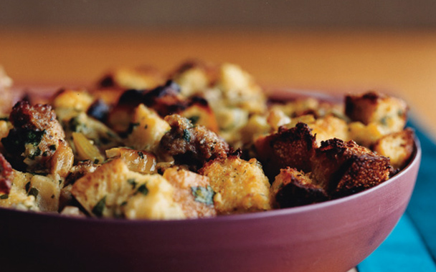

ITALIAN SAUSAGE AND BREAD STUFFING
SERVES8 (SIDE DISH)
- ACTIVE TIME:45 MIN START TO FINISH:2 1/4 HR
NOVEMBER 2007
This is the stuffing of your dreams, in which everything is a little more rustic, rich, and intense than you remember.
- 1 (3/4- to 1-pound) round Italian loaf, cut into 1-inch cubes (8 cups)
- 2 tablespoons olive oil, divided
- 2 lb sweet Italian sausage, casings removed, divided
- 1 stick unsalted butter, cut into pieces
- 3 medium onions, chopped
- 4 large celery ribs, chopped
- 5 garlic cloves, minced
- 4 large eggs, lightly beaten
- 3/4 cup heavy cream, divided
- 1/2 cup turkey giblet stock or reduced-sodium chicken broth
- 1 cup grated Parmigiano-Reggiano (2 oz)
- 1/2 cup coarsely chopped flat-leaf parsley
EQUIPMENT:

- a 4-qt shallow ceramic or glass baking dish (14 by 10 by 2 3/4 inches)
- Preheat oven to 350°F with rack in middle. Generously butter baking dish.
- Put bread in 2 shallow baking pans and bake, switching position of pans halfway through baking, until just dried out, about 10 minutes.
- Heat 1 tablespoon oil in a 12-inch heavy skillet over medium-high heat until it shimmers, then cook half of sausage, stirring and breaking it into small pieces, until golden brown, about 6 minutes. Transfer with a slotted spoon to a large bowl. Brown remaining sausage in remaining tablespoon oil, transferring to bowl.
- Pour off fat from skillet and wipe clean. Heat butter over medium heat until foam subsides, then cook onions, celery, garlic, and 1/2 teaspoon each of salt and pepper, stirring occasionally, until golden, 12 to 15 minutes. Add vegetables and bread to sausage.
- Whisk together eggs, 1/2 cup cream, turkey stock, cheese, and parsley, then stir into stuffing and cool completely, about 30 minutes. Reserve 5 cups stuffing to stuff turkey and spoon remainder into baking dish, then drizzle with remaining 1/4 cup cream. Cover stuffing and chill.
- About 1 hour before stuffed turkey is finished roasting, bring dish of stuffing to room temperature. When turkey is done, increase oven temperature to 425°F and bake stuffing, covered tightly with foil, until hot throughout, about 20 minutes. Remove foil and bake until top is golden and crisp, about 15 minutes more.
COOKS’ NOTES:
- Bread can be toasted 3 days ahead and kept (once cool) in a sealed bag at room temperature.Stuffing can be prepared (but not baked) 4 hours before roasting turkey.If baking stuffing at the same time as potatoes, put stuffing in upper third of oven and potatoes in bottom third (allow extra time).

RECIPES BY GINA MARIE MIRAGLIA ERIQUEZ

PHOTOGRAPH BY DITTE ISAGER

